Mixed Review

Big Idea #1: If you have a situation where something’s behavior changes for different ranges of input, you should define your function piecewise. Write an equation for the behavior in each different range of input and say the range where that equation applies

Big Idea #2: $x(t)$ only tells you horizontal movement, $y(t)$ tells you vertical movement. You have to combine them to know the shape of the path.
You can combine them by solving the system of equations (isolate t and substitute).
1. a). If $x\left(t\right)=\sin\left(t\right)+1$ and $y\left(t\right)=2⋅sin(t)$ find a cartesian equation representing the path of the movement.
b). As time ranges from 0 to $∞$ the movement only covers some of the points along the path given by your equation. What’s the domain that represents the x-values actually visited as the point moves?
c). If $x\left(t\right)=t^{4}-2$ and $y\left(t\right)=t^{2}+1$ find a cartesian equation representing the path of the movement. As time ranges from 0 to $∞$ what’s the domain, representing the x-values actually visited as the point moves?

Big Idea #3: There are lots of x(t), y(t) equations that describe the same path. They’re different parameterizations of the path. They represent different movements along the path.
You can choose any x(t) equation you want. This controls the horizontal movement. Then you can replace x with your $x(t)$ equation to ensure that your y coordinate will be correct for the path you want.
2. Give two different parameterizations for the path $y=x-\sqrt[3]{x}$ .
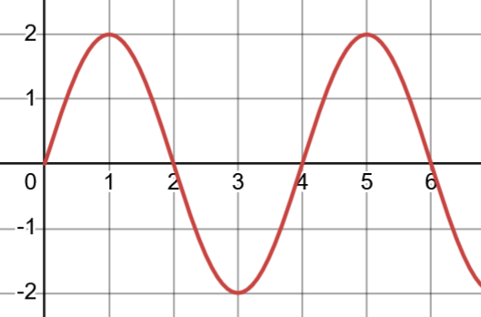
Describe what’s different about the movement for the equations you made.
t
x
3. Let $x\left(t\right)=2⋅sin\left(\frac{π}{2}t\right)$ (see graph to the right)
a). What can you say about this horizontal motion? Where is the x-value at t = 0? What happens to x as t increases? (t = 0, 1, 2, 3, etc.).
b). The $x(t)$ equation above can be used to create a linear path, a parabolic path, or a circular path (among other possibilities), depending on what $y(t)$ is.
Give examples of 3 different $y(t)$ equations that will produce a linear, a parabolic, and a circular path.
g Idea #3: If you want to control something with time … say an x-coordinate or an angle … make a graph with the information you want. Use it to write an equation.

Big Idea #4: If you want to control something with time … say an x-coordinate or an angle … make a graph with the information you want. Use it to write an equation.

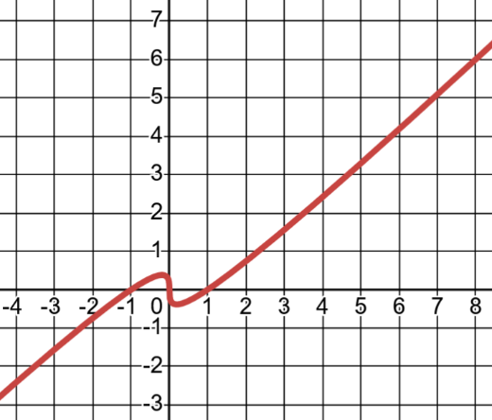
4.
a). I want to parameterize the path $y=x-\sqrt[3]{x}$ so we start at $(8,6)$ at t = 0 and move left, reaching $(-1, 0)$ at t = 6. (shown to the right).
Use the x-coordinate information to make an x(t) graph and equation first. Then find a y(t) equation that moves along the path we want.
b). $x\left(t\right)=cos(t)$ and $y\left(t\right)=sin⁡(t)$ represent a circular motion.
Modify the equations so that at $t=0$ the point starts at the top of the circle, moves counter-clockwise, and reaches the bottom of the circle at t = 3.
To do this, use the angle information to make an $A(t)$ graph and equation first. Then put $A(t)$ into the original equations so it will control the angle.

Vocab to know

SOLUTIONS

Big Idea #2: $x(t)$ only tells you horizontal movement, $y(t)$ tells you vertical movement. You have to combine them to know the shape of the path.
You can combine them by solving the system of equations (isolate t and substitute).
1. a). If $x\left(t\right)=\sin\left(t\right)+1$ and $y\left(t\right)=2⋅sin(t)$ find a cartesian equation representing the path of the movement.
Since $sin(t)$ is in both equations, I can isolate $\sin\left(t\right)$ and substitute.
$x=\sin\left(t\right)+1$ $\sin\left(t\right)=x-1$ … now I can substitute $x-1$ for $\sin\left(t\right)$
$y=2⋅\sin\left(t\right)$ $y=2(x-1)$

b). As time ranges from 0 to $∞$ the movement only covers some of the points along the path given by your equation. What’s the domain that represents the x-values actually visited as the point moves?
The x-coordinates I visit are determined by $x\left(t\right)=\sin\left(t\right)+1$.
$\sin\left(t\right)$ is always between -1 and 1. So $x(t)$ is always between 0 and 2. Therefore, even though the particle is moving along the line $y=2\left(x-1\right)$ it is on the restricted domain of $0≤x≤2$.

c). If $x\left(t\right)=t^{4}-2$ and $y\left(t\right)=t^{2}+1$ find a cartesian equation representing the path of the movement. As time ranges from 0 to $∞$ what’s the domain, representing the x-values actually visited as the point moves?
I could isolate t in the $x(t)$ equation and substitute like this:
$x=t^{4}-2$ $t=\sqrt[4]{x+2}$ so: $y={\left(\sqrt[4]{x+2}\right)}^{2}+1=\sqrt{x+2}+1$
But what if you didn’t remember how to simplify ${\left(\sqrt[4]{x+2}\right)}^{2}$ ?
When I look at the $x(t)$ and $y(t)$ equations, I see that $t^{4}$ is ${\left(t^{2}\right)}^{2}$. That tells me I could isolate $t^{2}$ in the y equation.
$y=t^{2}+1$ $y-1=t^{2}$ and now substitute that into the $x\left(t\right)$ equation
$x={\left(t^{2}\right)}^{2}-2$ $x={\left(y-1\right)}^{2}-2$
Solving for $y$ gives: $\sqrt{x+2}+1=y$
Either way is ok!

Big Idea #3: There are lots of x(t), y(t) equations that describe the same path. They’re different parameterizations of the path. They represent different movements along the path.
You can choose any x(t) equation you want. This controls the horizontal movement. Then you can replace x with your $x(t)$ equation to ensure that your y coordinate will be correct for the path you want.
2. Give two different parameterizations for the path $y=x-\sqrt[3]{x}$
Clearly there are lots of solutions here. For the first, I’ll choose an $x\left(t\right)=10-t$. Your choice of $x(t)$ can be literally anything. Since that tells me the x coordinate, I can substitute it for x. $y=\left(10-t\right)-\sqrt[3]{10-t}$
You can see that y is a function of time (since to get a value for y I need to plug in a value of t). We can write that explicitly by saying $y\left(t\right)=\left(10-t\right)-\sqrt[3]{10-t}$.
SO: One set of solutions is:
$$x\left(t\right)=10-t$$
$y\left(t\right)=\left(10-t\right)-\sqrt[3]{10-t}$.

Let’s choose a different $x(t)$. What if $x\left(t\right)=t^{2}$. Then $y\left(t\right)=t^{2}-\sqrt[3]{t^{2}}$. So:
$$x\left(t\right)=t^{2}$$
$$y\left(t\right)=t^{2}-\sqrt[3]{t^{2}}$$

Describe what’s different about the movement for the equations you made.
For the first solution, $x\left(t\right)=10-t$ so at $t=0$ the point start at $x=10$. As t increases, $x$ decreases, so the point is moving left (at a constant horizontal speed).
For the second solution $x\left(t\right)=t^{2}$. So at $t=0$ the point starts at $x=0$. As t increases, x increases. Not just that, but increases at an increasing rate. (In other words $x\left(t\right)=2t$ is a function where x also increases as t does, but at a constant rate of 2. If our units are feet and seconds, then it would be 2 ft/sec). The amount x increases by in each second is itself increasing for the $x=t^{2}$ function. That means the point is accelerating to the right.
3. Let $x\left(t\right)=2⋅sin\left(\frac{π}{2}t\right)$ (see graph to the right)

a). What can you say about this horizontal motion? Where is the x-value at t = 0? What happens to x as t increases? (t = 0, 1, 2, 3, etc.).
t
x
At $t=0$ the x value is also 0. As t increases, x goes up to 2, then reverses direction to go down to -2 (at t = 3), then reverses direction again to go up to 2 (at t = 5) and so on. In other words, it oscillates between -2 and 2 every 2 seconds.
b). The $x(t)$ equation above can be used to create a linear path, a parabolic path, or a circular path (among other possibilities), depending on what $y(t)$ is.
Give examples of 3 different $y(t)$ equations that will produce a linear, a parabolic, and a circular path.
Let’s say I want my linear path to be $y=10x+1$
If $x\left(t\right)=2⋅sin\left(\frac{π}{2}t\right)$ then $y\left(t\right)=10\left(2⋅sin\left(\frac{π}{2}t\right)\right)+1=20\sin\left(\frac{π}{2}t\right)+1$
Say I want my parabolic path to be $y=9-x^{2}$
Again, with $x\left(t\right)=2⋅sin\left(\frac{π}{2}t\right)$, my $y\left(t\right)=9-{\left(2⋅sin\left(\frac{π}{2}t\right) \right)}^{2}$
Typically, our circular path is given by $x\left(t\right)=cos⁡(t)$ and $y\left(t\right)=sin⁡(t)$ (maybe with some adjustments). Here the problem says that $x\left(t\right)$ must be $x\left(t\right)=2⋅\sin\left(\frac{π}{2}t\right)$.
Remember that $x\left(t\right)=sin(t)$ and $y\left(t\right)=\cos\left(t\right)$ also make a circular path. It’s just one where the point starts at (0, 1) at $t=0$. If $x\left(t\right)=2⋅\sin\left(\frac{π}{2}t\right)$, we’ve scaled the x coordinate by 2 and increased the rotational rate. If we want the movement to be circular we need to do the same things to $y(t)$.
So: $x\left(t\right)=2⋅\sin\left(\frac{π}{2}t\right)$ and $y\left(t\right)=2⋅\cos\left(\frac{π}{2}t\right)$.
Big Idea #4: If you want to control something with time … say an x-coordinate or an angle … make a graph with the information you want. Use it to write an equation.


4.
a). I want to parameterize the path $y=x-\sqrt[3]{x}$ so we start at $(8,6)$ at t = 0 and move left, reaching $(-1, 0)$ at t = 6. (shown to the right).
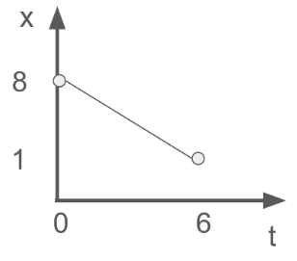
Here’s a tiny graph of what I want $x(t)$ to do. This gives $x\left(t\right)=-\frac{7}{6}t+8$
Plugging this into the path gives:
$y\left(t\right)=-\frac{7}{6}t+8-\sqrt[3]{-\frac{7}{6}t+8}$

b). $x\left(t\right)=cos(t)$ and $y\left(t\right)=sin⁡(t)$ represent a circular motion.
Modify the equations so that at $t=0$ the point starts at the top of the circle, moves counter-clockwise, and reaches the bottom of the circle at t = 3.
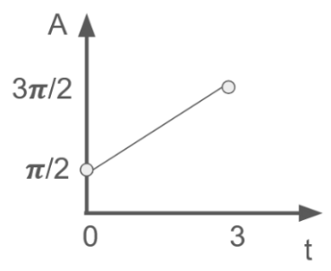
This time my graph is for $A(t)$ since I want to control the angle with time (instead of the x-coordinate with time).
This gives $A\left(t\right)=\frac{π}{3}t+\frac{π}{2}$ .
Circular motion is $x\left(t\right)=\cos\left(angle\right)$ and $y\left(t\right)=\sin\left(angle\right)$

Here our angle is a function of time. So: $x\left(t\right)=\cos\left(\frac{π}{3}t+\frac{π}{2}\right)$ and $y\left(t\right)=\sin\left(\frac{π}{3}t+\frac{π}{2}\right)$

